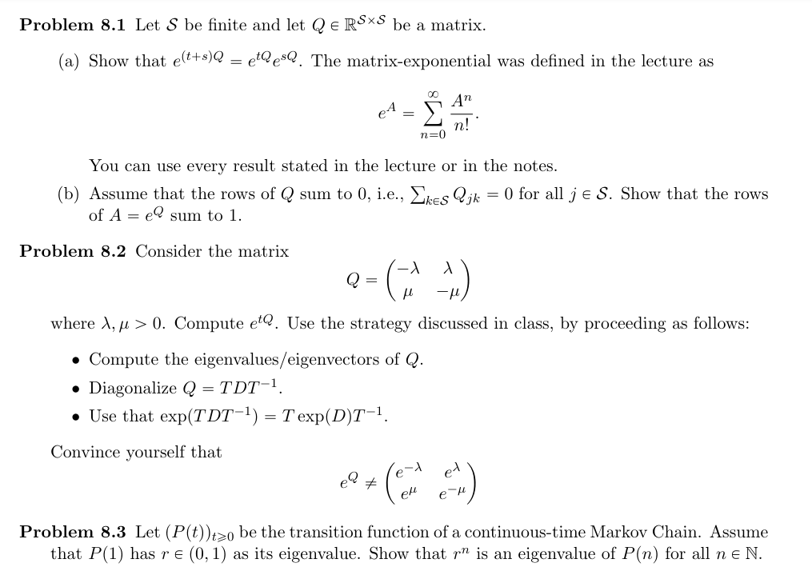

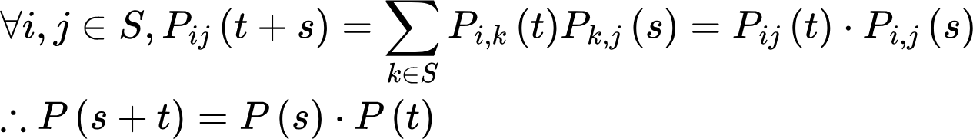



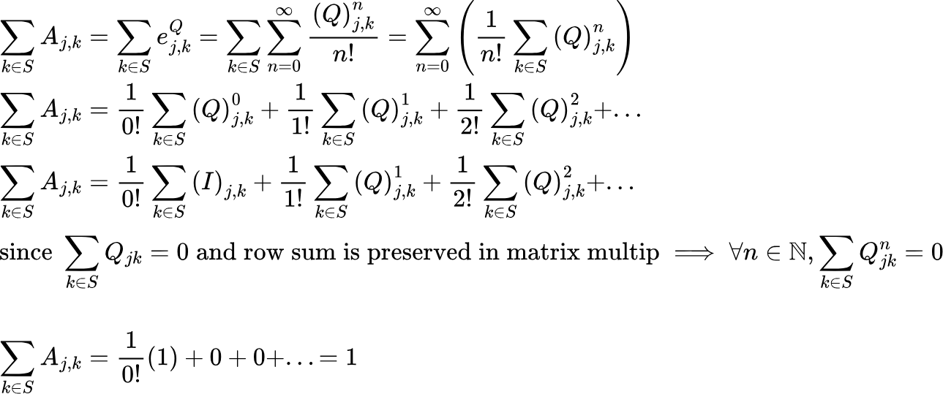



{"backgroundColor":"#ffffff","aid":null,"code":"\\begin{lalign*}\n&{Q=\\begin{bmatrix}\n{-\\lambda}&{\\lambda}\\\\\n{\\mu}&{-\\mu}\\\\\n\\end{bmatrix}}\\\\\n&{\\det\\left(Q-tI\\right)=\\det\\left(\\begin{bmatrix}\n{-\\lambda-t}&{\\lambda}\\\\\n{\\mu}&{-\\mu-t}\\\\\n\\end{bmatrix}\\right)=\\left(-\\lambda-t\\right)\\left(-\\mu-t\\right)-\\left(\\lambda\\right)\\left(\\mu\\right)}\\\\\n&{\\det\\left(Q-tI\\right)=t^{2}+\\left(\\mu+\\lambda\\right)t+\\mu\\lambda-\\mu\\lambda=t\\left(t+\\mu+\\lambda\\right)=0}\\\\\n&{\\implies t=0,-\\left(\\mu+\\lambda\\right)}\\\\\n&{}\\\\\n&{\\left(\\begin{bmatrix}\n{-\\lambda}&{\\lambda}\\\\\n{\\mu}&{-\\mu}\\\\\n\\end{bmatrix}-0\\cdot I\\right)\\begin{bmatrix}\n{a}\\\\\n{b}\\\\\n\\end{bmatrix}=\\begin{bmatrix}\n{-\\lambda}&{\\lambda}\\\\\n{\\mu}&{-\\mu}\\\\\n\\end{bmatrix}\\begin{bmatrix}\n{a}\\\\\n{b}\\\\\n\\end{bmatrix}=\\begin{bmatrix}\n{0}\\\\\n{0}\\\\\n\\end{bmatrix}\\implies v_{1}=\\begin{bmatrix}\n{1}\\\\\n{1}\\\\\n\\end{bmatrix}}\\\\\n&{\\left(\\begin{bmatrix}\n{-\\lambda}&{\\lambda}\\\\\n{\\mu}&{-\\mu}\\\\\n\\end{bmatrix}-\\left(-\\left(\\mu+\\lambda\\right)\\right)I\\right)\\begin{bmatrix}\n{a}\\\\\n{b}\\\\\n\\end{bmatrix}=\\begin{bmatrix}\n{\\mu}&{\\lambda}\\\\\n{\\mu}&{\\lambda}\\\\\n\\end{bmatrix}\\begin{bmatrix}\n{a}\\\\\n{b}\\\\\n\\end{bmatrix}}\\\\\n&{\\left(\\mu \\right)a+\\left(\\lambda\\right)b=0}\\\\\n&{-\\frac{\\mu}{\\lambda}a=b\\implies v_{2}=\\begin{bmatrix}\n{1}\\\\\n{-\\mu/\\lambda}\\\\\n\\end{bmatrix}}\\\\\n&{}\\\\\n&{T^{-1}=\\begin{bmatrix}\n{1}&{1}\\\\\n{1}&{-\\mu/\\lambda}\\\\\n\\end{bmatrix}^{-1}=\\frac{1}{1\\cdot-\\mu/\\lambda-1\\cdot1}\\begin{bmatrix}\n{\\mu/\\lambda}&{-1}\\\\\n{-1}&{1}\\\\\n\\end{bmatrix}=\\frac{1}{-\\mu/\\lambda-1}\\begin{bmatrix}\n{-\\mu/\\lambda}&{-1}\\\\\n{-1}&{1}\\\\\n\\end{bmatrix}=\\frac{\\lambda}{-\\mu-\\lambda}\\begin{bmatrix}\n{-\\mu/\\lambda}&{-1}\\\\\n{-1}&{1}\\\\\n\\end{bmatrix}}\\\\\n&{T^{-1}=\\begin{bmatrix}\n{\\frac{\\mu}{\\mu+\\lambda}}&{\\frac{\\lambda}{\\mu+\\lambda}}\\\\\n{\\frac{\\lambda}{\\mu+\\lambda}}&{\\frac{-\\lambda}{\\mu+\\lambda}}\\\\\n\\end{bmatrix}}\\\\\n&{}\\\\\n&{\\begin{bmatrix}\n{-\\lambda}&{\\lambda}\\\\\n{\\mu}&{-\\mu}\\\\\n\\end{bmatrix}=TDT^{-1}=\\begin{bmatrix}\n{1}&{1}\\\\\n{1}&{-\\mu/\\lambda}\\\\\n\\end{bmatrix}\\begin{bmatrix}\n{0}&{0}\\\\\n{0}&{-\\left(\\mu+\\lambda\\right)}\\\\\n\\end{bmatrix}\\begin{bmatrix}\n{\\frac{\\mu}{\\mu+\\lambda}}&{\\frac{\\lambda}{\\mu+\\lambda}}\\\\\n{\\frac{\\lambda}{\\mu+\\lambda}}&{\\frac{-\\lambda}{\\mu+\\lambda}}\\\\\n\\end{bmatrix}}\\\\\n&{}\\\\\n&{\\exp\\left(Q\\right)=\\exp\\left(TDT^{-1}\\right)=T\\exp\\left(D\\right)T^{-1}=T\\exp\\left(D\\right)T^{-1}=\\begin{bmatrix}\n{1}&{1}\\\\\n{1}&{-\\mu/\\lambda}\\\\\n\\end{bmatrix}\\begin{bmatrix}\n{e^{0}}&{0}\\\\\n{0}&{e^{-\\left(\\mu+\\lambda\\right)}}\\\\\n\\end{bmatrix}\\begin{bmatrix}\n{\\frac{\\mu}{\\mu+\\lambda}}&{\\frac{\\lambda}{\\mu+\\lambda}}\\\\\n{\\frac{\\lambda}{\\mu+\\lambda}}&{\\frac{-\\lambda}{\\mu+\\lambda}}\\\\\n\\end{bmatrix}}\\\\\n&{\\exp\\left(Q\\right)=\\begin{bmatrix}\n{1}&{1}\\\\\n{1}&{-\\mu/\\lambda}\\\\\n\\end{bmatrix}\\begin{bmatrix}\n{1}&{0}\\\\\n{0}&{e^{-\\left(\\mu+\\lambda\\right)}}\\\\\n\\end{bmatrix}\\begin{bmatrix}\n{\\frac{\\mu}{\\mu+\\lambda}}&{\\frac{\\lambda}{\\mu+\\lambda}}\\\\\n{\\frac{\\lambda}{\\mu+\\lambda}}&{\\frac{-\\lambda}{\\mu+\\lambda}}\\\\\n\\end{bmatrix}\\neq\\begin{bmatrix}\n{e^{-\\lambda}}&{e^{\\lambda}}\\\\\n{e^{\\mu}}&{e^{-\\mu}}\\\\\n\\end{bmatrix}}\t\n\\end{lalign*}","font":{"size":10,"color":"#000000","family":"Arial"},"type":"lalign*","id":"1","ts":1716938238968,"cs":"d5oV3ADldLccvhRLRSuQfQ==","size":{"width":700,"height":612}}



